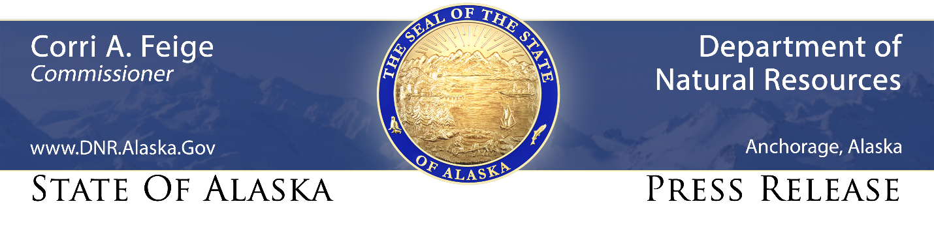
For Immediate Release: March 5, 2021

Palmer Fred Meyer harvests second “Golden Carrot” for 2020

(Palmer, AK) – The Fred Meyer store in the heart of Alaska’s agricultural district has won the “Golden Carrot” for a second year in a row, in recognition of its marketing creativity and success during the fourth-annual “Alaska Grown $5 Challenge” campaign.

“One of the many benefits of a strong farming industry is the confidence it provides to both retailers and consumers in the freshness, quality and value of Alaska Grown fruits and vegetables,” said Dave W. Schade, director of the Division of Agriculture. “Governor Dunleavy has said a successful agriculture industry is key to rebuilding Alaska’s economy, so it’s a pleasure to recognize this store’s consistent record of promoting Alaska produce.”

Schade presented the award to Palmer Fred Meyer store manager Dean Forkner and produce department manager Parker Collins this morning in a special ceremony inside the store, located at intersection of the Glenn and Palmer-Wasilla highways.

“This Palmer team really understands the importance of doing everything we can to promote and support local agriculture” said Forkner, who oversaw the staff whose efforts won the Golden Carrot in both 2019 and 2020. “I am proud their efforts are being acknowledged for two years running, and want to give special credit to Parker and his crew for all they did to make these wins possible”

The Alaska Grown $5 Challenge encourages Alaskans to spend $5 each week on Alaska Grown products, including vegetables, dairy products, meat and grains. The competition is held during the five months when more products are in season and available.

The division developed the program in conjunction with retailers across the state – including Carrs Safeway, Walmart, Fred Meyer, Three Bears, and Alaska Commercial Co. – to increase the amount and visibility of Alaska Grown products available in our retail food stores.

Previous “Golden Carrot” winners are the Palmer Fred Meyer store (2019), the Wasilla Walmart store (2018), and the Palmer Carrs-Safeway store (2017).

CONTACT: John Whipple, 907-761-3874, john.whipple@alaska.gov

###

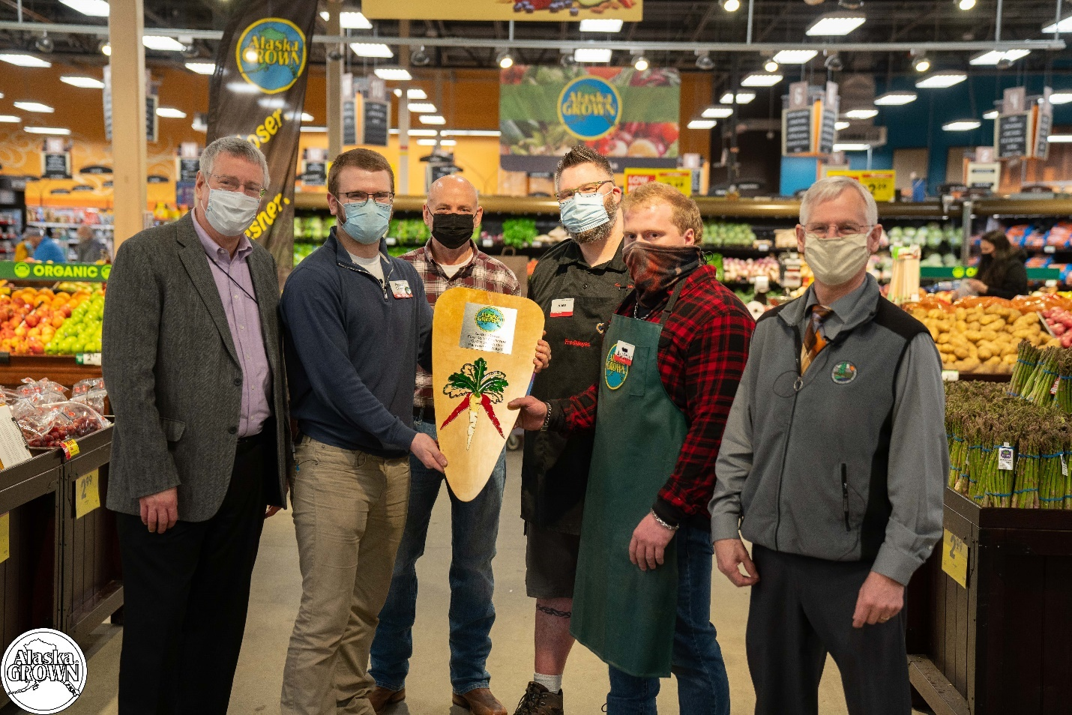

The Palmer Fred Meyer store won the “Golden Carrot” for a second year in a row, in recognition of its marketing creativity and success during the fourth-annual “Alaska Grown $5 Challenge” campaign. Attending Friday morning’s award ceremony were (L-R) DNR communications director Dan Saddler; store produce manager Parker Collins; store manager Dean Forkner; order clerk Ross Barnett; assistant produce manager Austin Loyer; and Division of Agriculture director David W. Schade.

